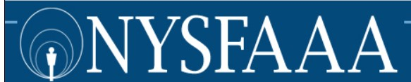

Dearest NYSFAAA Members:

It is with a very heavy heart that I must inform the membership that we (your Executive Council, 2020 Conference Chairs and I) have decided to cancel the 2020 Annual NYSFAAA Conference.
We considered many things before making this drastic decision. Our discussion included the possibility of the virus returning in the Fall and the likelihood that institutional budgets will be limited for travel and professional development for the 2020-2021 academic year.
I feel the need to apologize to all concerned, not that it is my fault. It is just the “sorry” that you say when something bad happens that is not at all under your control. We canceled Novice with the intent of doing a Novice track at the conference and now we have canceled the conference. To boot, we had to put a freeze on NASFAA Credentialing.
Not all news is bad. We remain a strong association. Regions are beginning to have virtual meetings and we are sure that things will return to some sense of normal soon.
At our next meeting, in June, we are going to discuss alternatives to a live conference. There will definitely be a business meeting as required by NYSFAAA Policy, and from there...... We will discuss. We always value input from our members, so please do not hesitate to contact me at president@nysfaaa.org<mailto:president@nysfaaa.org> or your regional Executive Council representatives. Remember – there are no bad ideas (they may be a little unrealistic, but they are not bad).
Thank you all for your understanding.

Howard Leslie
NYSFAAA President

