HOW TO USE
NYSFAAA Community Forum

The NYSFAAA Community Forum (NCF) is an area to bring up new topics (forums), or to reply to existing ones. It is a place for NYSFAAA members to commune, get guidance from fellow members and jointly work at solutions.
The forum categories displays on the main Forum page, and within them, specific forums related to those categories exist. Inside of each forum, members can post, view, and reply to Topics.
You get to NCF by logging into the website and clicking on Community Forum
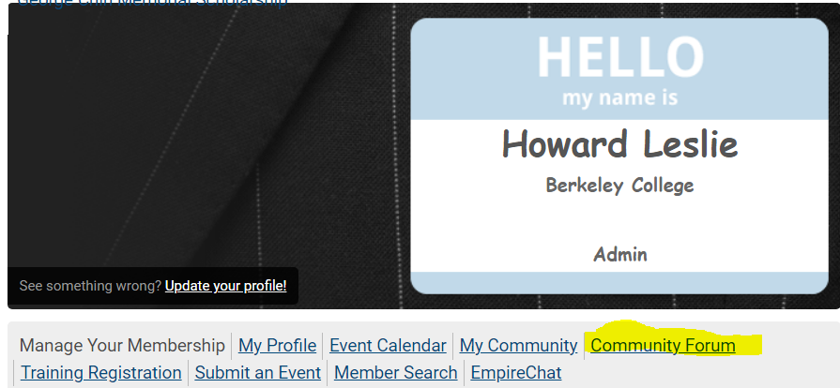
Then you will see our three (we can add others upon request) main discussion areas
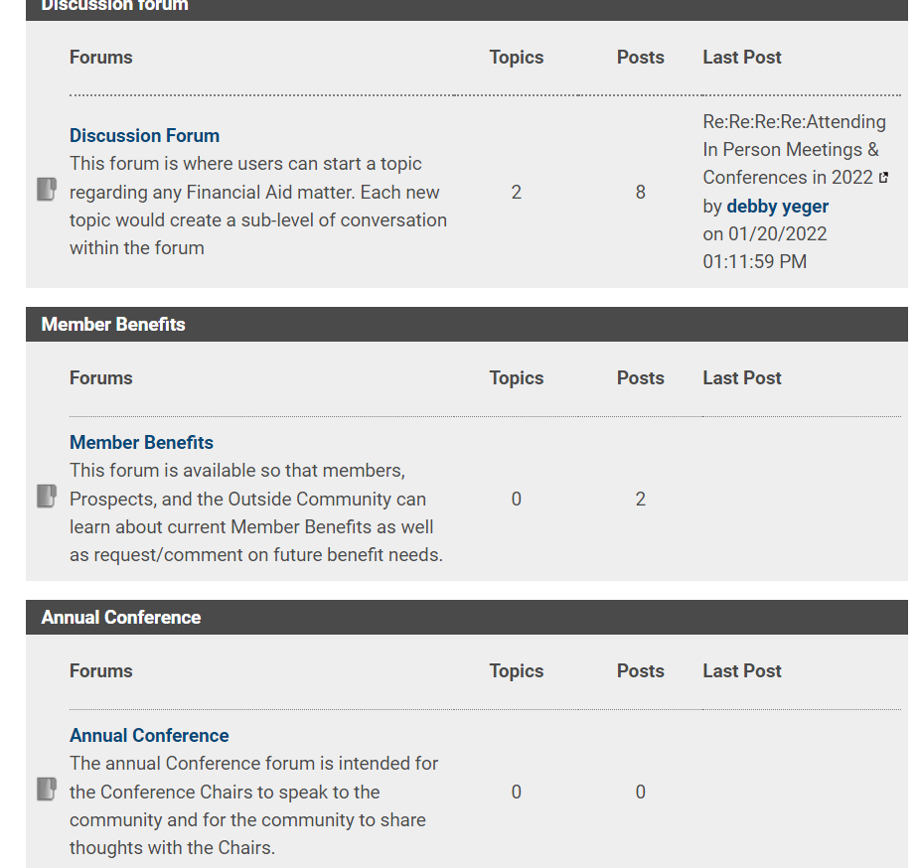
You will note that, as of this date:

Discussion Forum, which is open ended, currently has 8 post with 2 topics. You can create your own topic within each discussion area.
Those people that did not opt out, the vast majority, will receive an email when a new post or response to post is made. It creates an on going conversation that people can follow – even if not opted in.

To see the most recent posts – CLICK ON LATEST POSTS
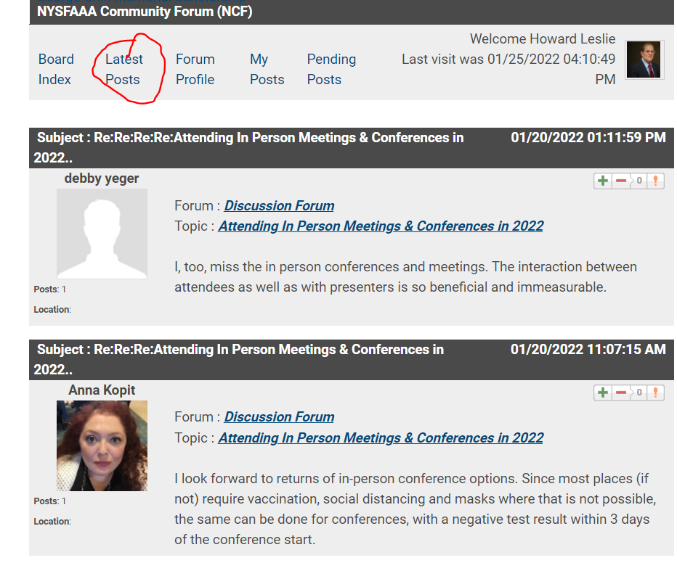
The above shows you the most recent posts to the Discussion Forum area, Thanks for Participating Deb and Anna.
You will note the forum name and the TOPIC (again, you cannot create forums about you can start or respond to topics.
A FEW IMPORTANT DETAILS
- Replying to the topic would add a new response to the topic list. Replies can include file attachments, which is perfect for meeting minutes, conference notes, etc.
- Subscribing to a topic means that anytime a user replies to a specific post, anyone who has clicked "Subscribe" will receive an email with a link to the forum post. Users can view a list of My Subscribes, where they can quickly un-subscribe from any topics no longer relevant to them.
- Favoriting a topic will add the topic to a user’s My Favorites list. This list is available anytime under My Posts, and can act as a running list of topics a user is interested in revisiting later. Unlike "Subscribe," users won’t receive emails when they favorite a topic, so this is a less intrusive way of staying up to date on topics relevant to you.
This information should certainly give you all you need to participate, solve issues and get answers from you colleagues.
SO WHAT ARE YOU WAITING FOR? This is a great new MEMBER BENEFIT – GO FOR IT!
Best Regard,
Lea and Howard, TICC Co-Chairs

